PSTU INFORMATION SYSTEM

AUTHOR NAME

**Md. Inzamul Islam Ricky**

PROJECT SUBMITTED IN FULFILMENT OF THE DEGREE OF

BACHELOR OF COMPUTER SCIENCE AND ENGINEERING

FACULTY OF COMPUTER SCIENCE AND ENGINEERING

PATUAKHALI SCIENCE AND TECHNOLOGY UNIVERSITY

2017

**DECLARATION OF ORIGINAL WORK**

I am declaring that the work presented in this project titled “PSTU Information System”, submitted to the Patuakhali Science and Technology University, for the award of the Bachelor of Computer Science and Engineering degree, is our original work. I have not plagiarized or submitted the same work for the award of any other degree. In-case this undertaking is found incorrect, I accept that my degree may be unconditionally withdrawn.

December, 2017

Place: Patuakhali.

………………..………………

Md. Inzamul Islam Ricky

**LETTER OF APPROVAL**

Certified that the work contained in the project titled “PSTU Information System”, by Md. Inzamul Islam Ricky, has been carried out under my supervision and that this work has not been submitted elsewhere for a degree.

Signature :

Supervisor Name : Dr. Syed Md. Galib

Department Name: Computer Science and Information Technology (CIT)

**…WEBSITE FEATURE…**

**“DEVELOPMENT OF PATUAKHALI SCIENCE AND TECHNOLOGY UNIVERSITY INFORMATION SYSTEM (UIS)”**

The title of the project is “DEVELOPMENT OF PATUAKHALI SCIENCE AND TECHNOLOGY UNIVERSITY INFORMATION SYSTEM”. This project will handle whole the whole information system of the university. Website of an organization can be considered as most effective and important way to reach to the viewers. A viewer can easily get any kind of information of an organization from its website. Organizations can provide various kinds of information, share news, get reviews from users and do a many more official work through a website. Now if we consider about our University system, most of the tasks are still done in old way. Most important among them is University Enrollment System. On every semester, every student need to fill up their enrollment form and for authentication purpose this process need to go through between various departments like: Bank, Account Officer (two times), Dean office etc. But think for a while about an Information System where student can complete their enrollment works just by staying in room. All authentication process will be done over online and student can check the current status of the process. And before exam, we need to go to Dean office for collecting admit card, but from the PIS website you can get you admit card online and then you just have to print it for academic purpose. On the same way a student can apply for his/her “Studentship Certificate” just from their PIS dashboard.

Not only for enrollment purpose, an information system supposed to store and deal with the all information of the University like: admission process, dynamic hall and faculty allocation, live chat with admin, and a social sharing page or Blog etc.

This project is developed in ASP.NET FRAMEWORK (MVC FRAMEWORK 5.0), ASP.NET WEB API and MICROSOFT SQL SERVER database In backend. For front end purpose, I have used HTML5, TWITTER BOOTSTRAP, CSS and JAVASCRIPT, AngularJS

**MODULES OF WEBSITE**

This project includes the following modules. These are given below:

* This system is all about the converting the almost whole information of University system from manual to online.
* Secured database system by Microsoft SQL Server.
* Account will be created on the time of admission, and those personal information will be stored for lifetime.
* Email Authentication based password changing option
* A well designed discussion forum or Blog.
* PIS members can post their words and also can post comments on their thinking.
* Members have their own blog profile from where they can remove unwanted comments and can edit/delete their own post.
* Well designed dashboard for every member students and all necessary action will be near at hand.
* Online chatting with site admin.
* Individual login system (Student, Teacher, Account Officer, Dean Office, Hall)
* View all semester course detail
* Enroll to next semester
* Enroll For Repeat Courses
* Check Enrollment Clearance from accountant and dean office
* Apply for hall clearance & Check approval of hall clearance
* Download PDF admit Card
* Download PDF Studentship Certificate
* Demo Bank API to check the transaction detail. When account officer want to approve a transaction, bank API will provide a JSON output corresponding to the transaction. So no need to interact with the bank database directly, at all.
* Account officer can approve a student for enrollment.
* Hall Provost Office can approve a transaction .
* Finally approval after accountant and hall provost request will be transferred to dean office. And dean office will finally approve it.
* Dean Office can control the enrollment & the admit card providing session
* Global API for providing Enrolling information.
* Student admission module:
  + Admin can upload A,B,C unit eligible student list and Final result in Microsoft Excel file.
  + Eligible student can provide information and download their admit card. They also can provide subject choice as well.
  + Every student will get their faculty and hall according to their merit list by an algorithm

**PROJECT CATEGORY:**

This project as title “PSTU Information System (PIS)” comes under the Relational Database Management System (RDBMS). This application is developed with the help of ASP.NET (MVC FRAMEWORK), HTML, CSS, JAVASCRIPT, Ajax and MICROSOFT SQL SERVER. This application can also be run on the network environment so it can be said as network application.

**TOOLS/PLATFORM**

This project is developed using the tools, which are most suited for development of the Application Package. These tools are as follows: -

1. HTML (For the front end).

2. CSS (Cascading style for all page).

3. Ajax

4. JAVASCRIPT

5. ASP.NET (For Back end programming)

6. MVC FRAMEWORK (Software Development Architecture)

7. ASP.NET WEB API

8. Razor (View Engine)

9. Entity Framework (Interacting with database)

10. Microsoft SQL Server (For Database Storage as Back end)

11. Twitter Bootstrap (For design purpose)

12. AngulaJS (For View Binding)

**HARDWARE & SOFTWARE REQUIREMENT**:

**Hardware:**

Any kind of desktop, laptop or notebook, mobile phone.

**Software**

Operating System: Windows

Database Server: Microsoft SQL Server 2012

IDE: Microsoft Visual Studio 2013

**Benefit:**

This project is based on the RDBMS technology; the main objective of this project is to computerize the manual system & reduce the time consumption. In otherworld’s we can say that our project has the following objectives:-

**The benefits for Information System**

* Reduction on working cost
* Less paper work
* Online based data accessibility and storage
* Data accessibility from everywhere
* Justifying the slogan “Information For All”
* Marging total admission system with University Information site, including download admit card, subject choice and dynamic hall and faculty allocation
* Global API link for collecting enrollment information.

**The benefits for Students:**

* Easy and Online enrollment system
* Download admit card directly from UIS site
* Download Studentship Certificate direct from UIS site
* Official Online forum or Blog
* Easily access of information
* Dynamic changeable class online routine
* Live chat with site controller

**ACKNOWLEDGEMENTS**

Alhamdulillah, at first, I show my deepest gratitude to the Allah Subhanu-ta-ala to allow me to complete this project report in time.

I am deeply indebted to my project supervisor Dr. Syed Md. Galib, Associate Professor, department of CIT, faculty of Computer Science and Engineering, Patuakhali Science and Technology University, for letting me choose this topic and providing with his invaluable comment on each chapter of this report and provided us his whole-hearted support to prepare the report in a well-organized manner.

We are also grateful to my honorable project Co Supervisor Dr. Md. Samsuzzaman, Associate Professor, department of CCE, faculty of Computer Science and Engineering, Patuakhali Science and Technology University, for their guidance and providing valuable information as well as helping us by their valuable supportive opinions.

Finally, thanks to all our friends of the CSE 11th batch for their overall support and co- operation to complete our project report in time.

**CONTENTS**

|  |  |
| --- | --- |
|  | Page |
| Declaration of Original Work…………………………............................................ | ii |
| Letter of Approval…………………………………………………………………. | iii |
| Website Feature……………………………………………………………………. | iv |
| Project Category…………………………………………………………………… | vi |
| Modules of Software……………………………………………………………… | v |
| Tools/Platform……………………………………………………………………... | vii |
| Hardware and Software Requirement…………………………………………….. | vii |
| Acknowledgements………………………………………………………………. | viii |
| Contents…………………………………………………………………………… | ix |

|  |  |  |
| --- | --- | --- |
| CHAPTER 1 | INTRODUCTION | 1 |
| 1.1 | Introduction………………………………………………………………… | 1 |
| 1.2 | Project Motivation………………………………………………………….. | 1 |
| 1.3 | Objectives…………………………………………………………………... | 1 |
|  | 1.3.1 Specific Objectives………………………………………………….. | 2 |
|  | 1.3.2 Overall Objectives…………………………………………………... | 2 |
| 1.4 | Project Schedule……………………………………………………………. | 2 |
|  |  |  |
| CHAPTER 2 | ACTIVITIES OF SOFTWARE DEVELOPMENT LIFE CYCLE (SDLC) | 3 |
| 2.1 | Introduction………………………………………………………………… | 3 |
| 2.1.1 | Some Information On SDLC ……………………………………………… | 3 |
| 2.1.2 | Brief Detail of each Stage in SDLC …………….…………………………. | 4 |
| 2.3 | Waterfall Model Design……………………………………………………. | 5 |
|  | 2.3.1 Requirement Gathering and Analysis……………………………….. | 7 |
|  | 2.3.2 System Design………………………………………………………. | 7 |
|  | 2.3.3 Implementation……………………………………………………… | 7 |
|  | 2.3.4 Integration and Testing……………………………………………… | 7 |
|  | 2.3.5 Deployment of System……………………………………………… | 7 |
|  | 2.3.6 Maintenance…………………………………………………………. | 7 |
| 2.4 | Waterfall Model Practical Case Study …………………………………….. | 7 |
|  | 2.4.1 Waterfall Model – Application ……………………………………... | 8 |
|  | 2.4.2 Waterfall Model – Advantage ……………………………………… | 8 |
| 2.5 | Feasibility Study …………………… …………………………………….. | 9 |
|  | 2.5.1 Practically Feasible Software Process …………………………...... | 9 |
|  | 2.4.2 Financially Feasible ………. ……………………………………… | 9 |
| CHAPTER  3 | Requirements Modeling | 10 |
| 3.1 | Use Case Diagram………………………………………………………… | 10 |
| 3.2 | Data Flow Diagram……………………………………………………….. | 15 |
| 3.3 | Entity Relationship Diagram ……………………………………………... | 17 |
|  |  |  |
| CHAPTER 4 | CODING WITH QUALITY MANAGEMENT AND  Implementation ……… …………………………………………………… | 19 |
| 4.1 | Introduction to coding……………………………………………………… | 19 |
|  |  |  |
| CHAPTER 5 | PROJECT LAYOUT  Project Layout ……… …………………………………………………… | 24 |
| CHAPTER 6.1 | LIMITATIONS, CONCLUSION & FUTURE WORK  Project Self – Evaluation and Limitation…………………………………… | 32 |
| 6.2 | Conclusion and future work ……………………………………………….. | 32 |
|  |  |  |
|  |  |  |
|  |  |  |

**LIST OF TABLES**

|  |  |  |  |
| --- | --- | --- | --- |
| Sl. No | Table No. | Table Name | Page |
| 1 | Table 1.4 | Project Schedule Chart…….………….……………….….…. | 2 |
| 2 | Table 2.5.2 | Financial Feasibility Scenario 1……………..………..……... | 9 |
| 3 | Table 2.5.2 | Financial Feasibility Scenario 2…………………...……........ | 9 |

**LIST OF FIGURES**

|  |  |  |  |
| --- | --- | --- | --- |
| Sl. No | Fig No. | Figure Name | Page |
| 1 | Fig 2.1: | SDLC Life Cycle ...………………....……………………… | 3 |
| 2 | Fig 2.2 | Water Fall Model ……….…………….…………………….. | 6 |
| 3 | Fig 3.1 | Use Case Diagram Of Dean Office Activity.…….................. | 10 |
| 4 | Fig 3.2 | Use Case Diagram Of Account Officer Activity……............. | 10 |
| 5 | Fig 3.3 | Use Case Diagram Of Hall Provost Activity…….……......... | 11 |
| 6 | Fig 3.4 | Use Case Diagram Of Site Controller Activity…………….. | 11 |
| 7 | Fig 3.5 | Use Case Diagram Of Student Activity…..………………… | 12 |
| 8 | Fig 3.6 | Use Case Diagram Of Admission Applicant ……………….. | 13 |
| 9 | Fig 3.7 | Use Case Diagram Of Admission Admin Activity………… | 14 |
| 10 | Fig 3.8 | DFD Of Information System (1)……………………………. | 15 |
| 11 | Fig 3.9 | DFD Of Information System (2)……………………………. | 16 |
| 12 | Fig 3.10 | Entity Relationship Diagram (1)………………………….... | 17 |
| 13 | Fig 3.11 | Entity Relationship Diagram (1)…………………….……... | 18 |
| 14 | Fig 5.1 | UIS Members Fourm……………………………………….. | 24 |
| 15 | Fig 5.2 | Mail Auth. Password Change ……………………….……… | 24 |
| 16 | Fig 5.3 | Next Semester Enrolling Window ………………………….. | 25 |
| 17 | Fig 5.4 | Check Enrollment Status…………………………………….. | 25 |
| 18 | Fig 5.5 | Transaction Checking With Bank API…….………………... | 26 |
| 19 | Fig 5.6 | FI Course Selection …….…………………………………... | 26 |
| 20 | Fig 5.7 | Enrolled Semesters………………………………………….. | 27 |
| 21 | Fig 5.8 | Download Admit Card………………………………….…... | 27 |
| 22 | Fig 5.9 | Download Studentship Certificate …………………….…... | 28 |
| 23 | Fig 5.10 | Live Chat with Admin………………………………………. | 28 |
| 24 | Fig 5.11 | A-Unit Subject & Hall Choice ……...………………………. | 29 |
| 25 | Fig 5.12 | A-Unit Dynamic Faculty & Hall Allocation………………… | 29 |

CHAPTER 1

* 1. **INTRODUCTION**

The Purpose of the project is to develop the Information System website of Patuakhali Science and Technology University (PSTU) and provide a dynamic and responsive information system management system. Still now there’s not any dynamic information system in university and are students enrollment systems are still done by students manually. Not only enrollment system, as our Digital Bangladesh is growing with technology, we must ensure ‘Information For All’ slogan to be established in each organization. So as a government organization we need to make ensure the information should be access able to anywhere anytime. This Online information system can provide us many advantages like: Online based student enrollment system, online admit card and studentship certificate providing system, Members discussion forum, Online Journal publication etc. This Project is developed by ASP.NET MVC Framework, and MICROSOFT SQL SERVER database in backend and HTML5, JAVASCRIPT, CSS, BOOTSTRAP in frontend.

* 1. **PROJECT MOTIVATION**

1. Our Patuakhali Science and Technology University was established on 2000. But there is no any website where someone get the University information system accumulated in a single entity. So to avoiding this, we got a plan to develop a information system website, where everyone can access the university information anytime from anywhere.
2. Among the University of Bangladesh only Bangladesh University Of Engineering and Technology (BUET) is successfully using their information system website from where students can enroll to next semesters, they can apply for different scholarships , they can see their transaction history, payment info, and due status etc. So it was one of the motivation for me to develop that kind of information system in our University also.
3. And third motivation is my interest on web developing. I was very interested on Microsoft technology from the very beginning and I learnt Dot Net and C# on previous year. As my final year project I took PSTU Information System and beginning of the semester I learn MVC framework myself just to work on the project. It was on my motivation also. Then I also learnt some other javascript stuffs like ajax, anuglaJS etc and implemented in my project.
   1. **OBJECTIVES**
      1. **Specific Objective**
4. Introducing a new dynamic website for Patuakhali Science and Technology University which is full of relevant information and easy to use (User Friendly) where students, teachers, Hall provosts have different user panel for fulfillment of different purpose.
5. Automation of the Enrollment system,admission and other stuffs related to information system.
6. To make sure that information is available for all and everyone related to their activity can access through the information anytime anywhere.
   * 1. **OVERALL OBJECTIVES**

To be acquainted with the web development tools, namely HTML5, CSS, JAVASCRIPT,ANGULARJS and ASP.NET MVC, ASP.NET WEB API and for database MICROSOFT SQL SEVER MANAGEMENT STUDIO.

* 1. **PROJECT SCHEDULE**

|  |  |  |  |  |  |  |
| --- | --- | --- | --- | --- | --- | --- |
| **S/N** | **Activities** | **Date** | | | **Total Days** | **Status** |
| **From** | | **To** |
| 1 | Project initiated On | 20/01/2017 | | | 1 | Done |
| 2 | Submission of Draft Project Proposal | 13/03/17 | 15/03/17 | | 2 | Done |
| 3 | Communication and Understanding Requirements | 20/03/17 | 24/04/17 | | 5 | Done |
| 4 | Coding and Testing | 01/05/17 | 01/11/17 | | 128 | Developing. |
| 5 | Project Ends with an Presentation on | 25/12/2017 | | | 1 | Done |

Chapter 2

**Software Development Life Cycle (SDLC)**

**2.1 INTRODUCTION**

SDLC is a process followed for a software project, within a software organization. It consists of a detailed plan describing how to develop, maintain, replace and alter or enhance specific software. The life cycle defines a methodology for improving the quality of software and the overall development process.

**2.1.1 SOME INFORMATION ON SDLC**

* SDLC is the acronym of Software Development Life Cycle.
* It is also called as Software Development Process.
* SDLC is a framework defining tasks performed at each step in the software development process.
* ISO/IEC 12207 is an international standard for software life-cycle processes. It aims to be the standard that defines all the tasks required for developing and maintaining software.

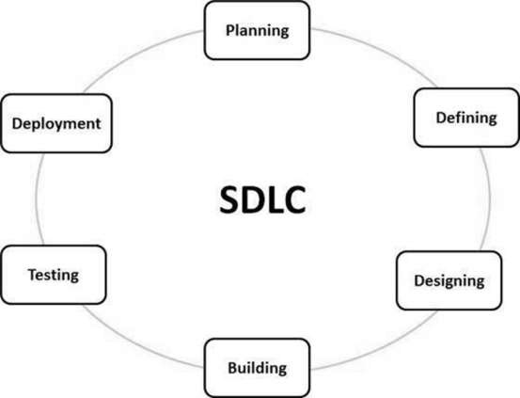

**Fig 2.1 : SDLC Life Cycle**

**2.1.2 Brief Detail of Each Stage in SDLC**

### **Stage 1: Planning and Requirement Analysis**

Requirement analysis is the most important and fundamental stage in SDLC. It is performed by the senior members of the team with inputs from the customer, the sales department, market surveys and domain experts in the industry. This information is then used to plan the basic project approach and to conduct product feasibility study in the economical, operational and technical areas.

Planning for the quality assurance requirements and identification of the risks associated with the project is also done in the planning stage. The outcome of the technical feasibility study is to define the various technical approaches that can be followed to implement the project successfully with minimum risks.

### **Stage 2: Defining Requirements**

Once the requirement analysis is done the next step is to clearly define and document the product requirements and get them approved from the customer or the market analysts. This is done through an **SRS (Software Requirement Specification)** document which consists of all the product requirements to be designed and developed during the project life cycle.

### **Stage 3: Designing the Product Architecture**

SRS is the reference for product architects to come out with the best architecture for the product to be developed. Based on the requirements specified in SRS, usually more than one design approach for the product architecture is proposed and documented in a DDS - Design Document Specification.

This DDS is reviewed by all the important stakeholders and based on various parameters as risk assessment, product robustness, design modularity, budget and time constraints, the best design approach is selected for the product.

A design approach clearly defines all the architectural modules of the product along with its communication and data flow representation with the external and third party modules (if any). The internal design of all the modules of the proposed architecture should be clearly defined with the minutest of the details in DDS.

### **Stage 4: Building or Developing the Product**

In this stage of SDLC the actual development starts and the product is built. The programming code is generated as per DDS during this stage. If the design is performed in a detailed and organized manner, code generation can be accomplished without much hassle.

Developers must follow the coding guidelines defined by their organization and programming tools like compilers, interpreters, debuggers, etc. are used to generate the code. Different high level programming languages such as C, C++, Pascal, Java and PHP are used for coding. The programming language is chosen with respect to the type of software being developed.

### **Stage 5: Testing the Product**

This stage is usually a subset of all the stages as in the modern SDLC models, the testing activities are mostly involved in all the stages of SDLC. However, this stage refers to the testing only stage of the product where product defects are reported, tracked, fixed and retested, until the product reaches the quality standards defined in the SRS.

### **Stage 6: Deployment in the Market and Maintenance**

Once the product is tested and ready to be deployed it is released formally in the appropriate market. Sometimes product deployment happens in stages as per the business strategy of that organization. The product may first be released in a limited segment and tested in the real business environment (UAT- User acceptance testing).

Our supervisor gave his consent verbally and we have asked for the required SDLC Models .It’s a type of project plan, and a number of different SDLC methodologies are used today to guide your way through projects. Most Familiar of them:

1. Waterfall Model
2. V shaped Model
3. Iterative Model
4. Big Bang Model
5. Agile Model
   1. **WATERFALL MODEL DESIGN**

The Waterfall Model was the first Process Model to be introduced. It is also referred to as a **linear-sequential life cycle model**. It is very simple to understand and use. In a waterfall model, each phase must be completed before the next phase can begin and there is no overlapping in the phases. The Waterfall model is the earliest SDLC approach that was used for software development.

The waterfall Model illustrates the software development process in a linear sequential flow. This means that any phase in the development process begins only if the previous phase is complete. In this waterfall model, the phases do not overlap.

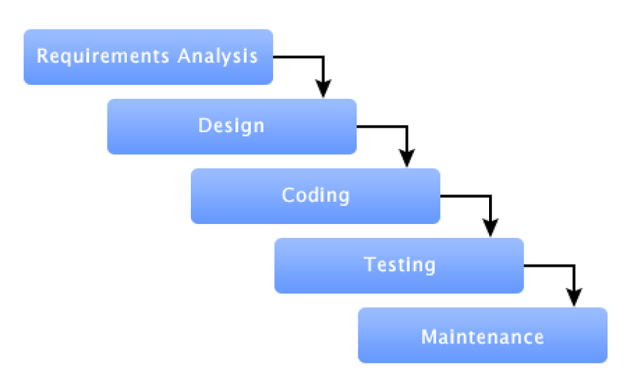

**Fig 2.2 : Waterfall model**

The sequential detail of waterfall model Phases :

* + 1. **Requirement Gathering and analysis** − All possible requirements of the system to be developed are captured in this phase and documented in a requirement specification document.
    2. **System Design** − The requirement specifications from first phase are studied in this phase and the system design is prepared. This system design helps in specifying hardware and system requirements and helps in defining the overall system architecture.
    3. **Implementation** − With inputs from the system design, the system is first developed in small programs called units, which are integrated in the next phase. Each unit is developed and tested for its functionality, which is referred to as Unit Testing.
    4. **Integration and Testing** − All the units developed in the implementation phase are integrated into a system after testing of each unit. Post integration the entire system is tested for any faults and failures.
    5. **Deployment of system** − Once the functional and non-functional testing is done; the product is deployed in the customer environment or released into the market.
    6. **Maintenance** − There are some issues which come up in the client environment. To fix those issues, patches are released. Also to enhance the product some better versions are released. Maintenance is done to deliver these changes in the customer environment.
  1. **WATERFALL MODEL PRACTIAL CASE STUDY:**

**2.4.1 Waterfall Model - Application**

Every software developed is different and requires a suitable SDLC approach to be followed based on the internal and external factors. Some situations where the use of Waterfall model is most appropriate are −

* Requirements are very well documented, clear and fixed.
* Product definition is stable.
* Technology is understood and is not dynamic.
* There are no ambiguous requirements.
* Ample resources with required expertise are available to support the product.
* The project is short.

## 2.4.2 Waterfall Model - Advantages

The advantages of waterfall development are that it allows for departmentalization and control. A schedule can be set with deadlines for each stage of development and a product can proceed through the development process model phases one by one.Some of the major advantages of the Waterfall Model are as follows −

* Simple and easy to understand and use
* Easy to manage due to the rigidity of the model. Each phase has specific deliverables and a review process.
* Phases are processed and completed one at a time.
* Works well for smaller projects where requirements are very well understood.
* Clearly defined stages.
* Well understood milestones.
* Easy to arrange tasks.
* Process and results are well documented.

## 2.4.3 Waterfall Model - Disadvantages

The disadvantage of waterfall development is that it does not allow much reflection or revision. Once an application is in the testing stage, it is very difficult to go back and change something that was not well-documented or thought upon in the concept stage.

The major disadvantages of the Waterfall Model are as follows −

* No working software is produced until late during the life cycle.
* High amounts of risk and uncertainty.
* Not a good model for complex and object-oriented projects.
* Poor model for long and ongoing projects.
* Not suitable for the projects where requirements are at a moderate to high risk of changing. So, risk and uncertainty is high with this process model.
* It is difficult to measure progress within stages.
* Cannot accommodate changing requirements.
* Adjusting scope during the life cycle can end a project.

## Feasibility Study

### **Practically Feasible Software Process:** Still our University doesn’t belong to any Online Information Management System, so all the process are done manually done by the officers of different departments. So information isn’t access able for students and to others. For example, we can consider the enrollment system. On every semester at the beginning, students need to enroll, and it’s a very time consuming process. A student need to take receipt from the account officer with a signature, then he need to go to bank for submitting appropriate amount of money and then again come back to account office and take another signature. Then he/she need to deposit money to hall and take approval from the hall provost as well. Its just a single process, but very time consuming. With the help of information system website one can complete this formalities just from his room online.

### **Financially Feasible:**

This project is financially feasible and study result has been summarized in the following table -

|  |  |  |  |
| --- | --- | --- | --- |
| **Scenario # 1: Varsity has Purchased the Software from the Market.** | | | |
| **S/N** | **Name of the Product** | **Purchase Cost (in BDT)** | **AMC @ 20% from 2nd year onward** |
| 1 | PSTU Information System | 2,00,000/=  (Two Lakhs Only) | 30,000/=  (Thirty Thousand) |
|  | | | |
| **Scenario # 2: Varsity has Adopted the Software, which has been developed by a Student Of CSE , PSTU 11th batch** | | | |
| **S/N** | **Name of the Product** | **Purchase Cost (in BDT)** | **AMC @ 20% from 2nd year onward** |
| 1 | PSTU Information System | 40,000/= | Not Applicable |

Chapter 3

**REQUIREMENTS MODELING**

**3.1 Use Case Diagram**

Actor: Dean Office

Fig: Dean Office Data Flow Diagram

**Fig 3.1 : Use Case Diagram Of Dean Office Activity**

Actor: Account Officer

Fig: Account Officer Data Flow Diagram

**Fig 3.2 : Use Case Diagram Of Account Office Activity**

Actor: Hall Provost

Fig: Hall Provost Data Flow Diagram

**Fig 3.3 : Use Case Diagram Of Hall Provost Activity**

Actor: Controller

Fig: Controller Data Flow Diagram

**Fig 3.4 : Use Case Diagram Of Site Controller Activity**

Actor: Student

Fig: Student Data Flow Diagram

**3.2 Data Flow Diagram**

**Fig 3.5 : Use Case Diagram Of UIS Student Activity**

Actor: Admission Applicant

Fig: Student Data Flow Diagram

**3.2 Data Flow Diagram**

**Fig 3.6 : Use Case Diagram Of Admission Applicant Activity**

Actor: Admission Admin

Fig: Student Data Flow Diagram

**3.2 Data Flow Diagram**

**Fig 3.7 : Use Case Diagram Of Admission Admin Activity**

**3.2 Data Flow Diagram**

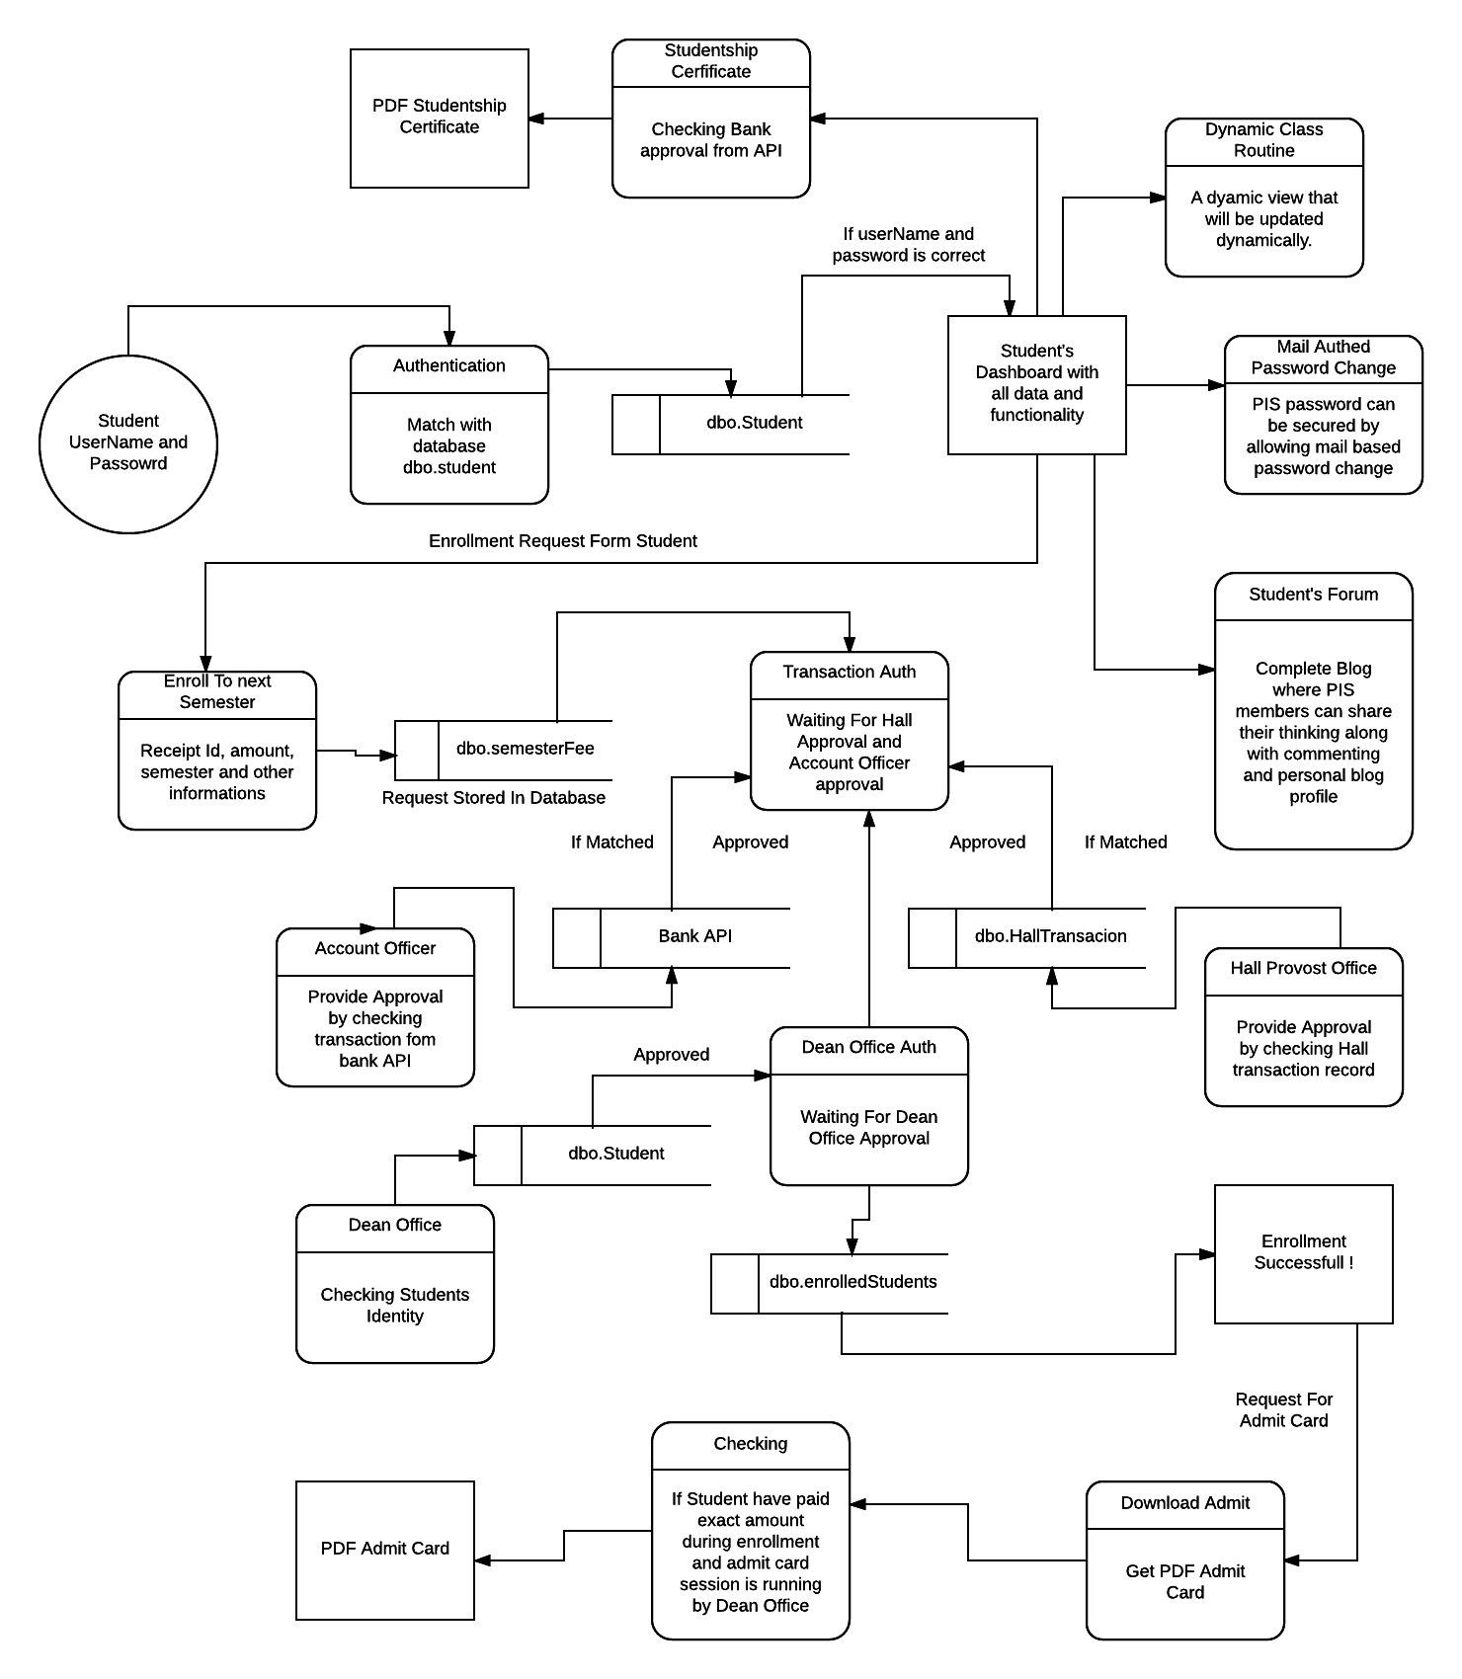

**Fig 3.8 : Data Flow Diagram Of Information System (Enroll,Blog,Bank API)**

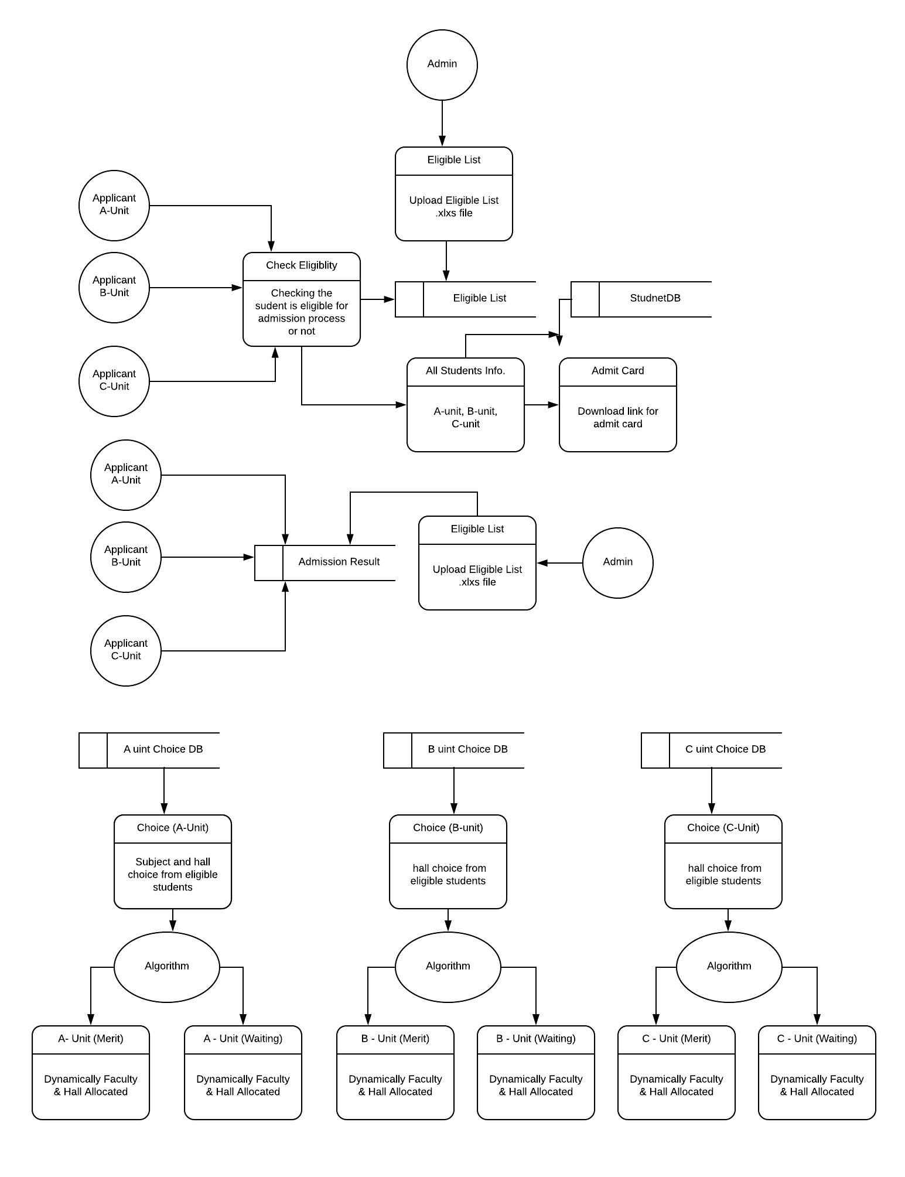

**Fig 3.9 : Data Flow Diagram Of Information System (Admission)**

**3.3 Entity Relationship (Generated From Microsoft Entity Framework Library)**

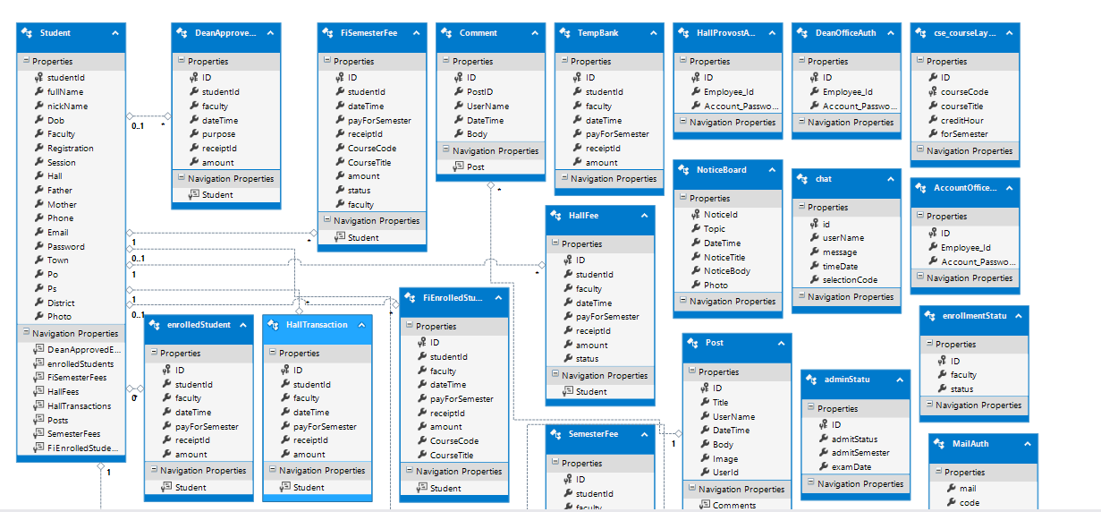

**Fig 3.10 : Entity Relationship Diagram (1)**

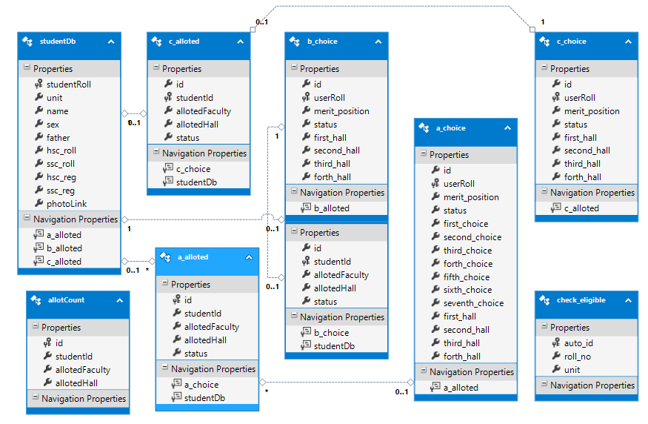

**Fig 3.11 : Entity Relationship Diagram (2)**

Chapter 4

**CODING WITH QUALITY MANAGEMENT AND IMPLEMENTATION**

**4.1 Introduction to Coding**

Developing error free executable program

**Enroll To Next Semester (SemesterFee) [Controller]**

**using System.Linq;**

**using System.Web;**

**using System.Web.Mvc;**

**using UIS.Models;**

**using System.Net;**

**using System.Dynamic;**

**namespace UIS.Controllers**

**{**

**public class SemesterFeeController : Controller**

**{**

**private UisContext db = new UisContext();**

**public ActionResult SubmitInfo()**

**{**

**var userId = Session["userId"].ToString();**

**var studentDetail = from s in db.Students select s;**

**if (userId != null)**

**{**

**studentDetail = studentDetail.Where(c => c.studentId == userId);**

**}**

**return View(studentDetail);**

**}**

**[HttpPost, ValidateInput(false)]**

**public ActionResult SubmitInfo(string receiptId, string payForSemester, float amount)**

**{**

**string userId = Session["userId"].ToString();**

**string userFaculty = Session["userFaculty"].ToString();**

**SemesterFee semesterFee = new SemesterFee();**

**semesterFee.studentId = userId;**

**semesterFee.faculty = userFaculty;**

**//**

**semesterFee.payForSemester = payForSemester;**

**semesterFee.receiptId = receiptId;**

**semesterFee.amount = amount;**

**semesterFee.dateTime = System.DateTime.Now.ToString();**

**semesterFee.hallClearance = "In Processing ...";**

**semesterFee.status = "In Processing ...";**

**db.SemesterFees.Add(semesterFee);**

**db.SaveChanges();**

**return RedirectToAction("SubmitInfo");**

**}**

**public ActionResult CheckStatus()**

**{**

**var userId = Session["userId"].ToString();**

**var studentFees = from s in db.SemesterFees select s;**

**if (userId != null)**

**{**

**studentFees = studentFees.Where(c => c.studentId == userId);**

**}**

**return View(studentFees);**

**}**

**public ActionResult StudentProfileForAccountant()**

**{**

**return View();**

**}**

**public ActionResult enrollingCourses(string enrolledSemester)**

**{**

**string faculty = Session["userFaculty"].ToString();**

**string userId = Session["userId"].ToString();**

**var semFeeCheck = (from p in db.SemesterFees where (p.studentId == userId) && (p.payForSemester == enrolledSemester) select p).FirstOrDefault();**

**var enrolledTableCheck = (from s in db.enrolledStudents where (s.studentId == userId) && (s.payForSemester == enrolledSemester) select s).FirstOrDefault();**

**if (semFeeCheck == null && enrolledTableCheck == null)**

**{**

**Session["enrolledSemester"] = enrolledSemester;**

**// if faculty is CSE**

**if (faculty == "CSE")**

**{**

**var courses = from s in db.cse_courseLayout select s;**

**if (courses != null)**

**{**

**courses = courses.Where(u => u.forSemester == enrolledSemester);**

**ViewBag.cseCreditHour = db.cse_courseLayout.Where(c => c.forSemester == enrolledSemester).Select(c => c.creditHour).DefaultIfEmpty().Sum();**

**return View(courses);**

**}**

**// return View();**

**}**

**}**

**else**

**{**

**return RedirectToAction ("AvailablityResult", "SemesterFee");**

**}**

**return View();**

**}**

**public ActionResult AvailablityResult ()**

**{**

**return View();**

**}**

**public ActionResult EnrolledSemesters()**

**{**

**var userId = Session["userId"].ToString();**

**var studentFees = from s in db.enrolledStudents select s;**

**if (userId != null)**

**{**

**studentFees = studentFees.Where(c => c.studentId == userId);**

**}**

**return View(studentFees);**

**}**

**Enroll To Next Semester (SubmitInfo) [View Page]**

**@using UIS.Models;**

**@model IEnumerable<Student>**

**@{**

**ViewBag.Title = "SubmitInfo";**

**Layout = "~/Views/Shared/_StudentInfoSideNav.cshtml";**

**}**

**<h1>@ViewBag.availablity</h1>**

**@{**

**foreach (var item in Model)**

**{**

**<div class="row">**

**<div class="col-lg-3">**

**<img src="~/proPic/@Html.DisplayFor(modelItem=>item.Photo)" alt="" class="img-thumbnail" width="150" height="150">**

**</div>**

**<div class="col-lg-6">**

**<h2>@Html.DisplayFor(modelItem => item.fullName) @Html.DisplayFor(modelItem => item.nickName) </h2>**

**<p><h2>Student ID: @Html.DisplayFor(modelItem => item.studentId) </h2></p>**

**<p><h2> Level:@Session["level"] / Semester: @Session["semester"] </h2></p>**

**</div>**

**<div class="col-lg-3">**

**</div>**

**</div>**

**}**

**}**

**<div>&nbsp; </div>**

**<div>&nbsp;</div>**

**<div class="container-fluid">**

**<div class="row">**

**<div class="col-md-2"></div>**

**<div class="col-md-8">**

**<div class="panel-group">**

**<div class="panel panel-success">**

**<div class="panel-heading">Start Enrollment For Next Semester</div>**

**<div class="panel-body">**

**@using (Html.BeginForm("enrollingCourses", "SemesterFee", FormMethod.Post, new { enctype = "multipart/form-data", name = "enrolledSemester", id = "enrolledSemester", onsubmit = "return validateForm()" }))**

**{**

**string varStatus = Session["enrollmentStatus"].ToString();**

**if (varStatus == "ON")**

**{**

**<marquee><h3 style="color:green ;">Enrollment Process Is Going On ... For More Information Check Your Noticeboard</h3></marquee>**

**}**

**else**

**{**

**<marquee><h3 style="color:red ;">Enrollment Process Is Stopped By Admin ...</h3></marquee>**

**}**

**<div>&nbsp;</div>**

**<div class="form-group">**

**<label for="sel1">Select Enrollment Semester:</label>**

**<select class="form-control" id="enrolledSemester" name="enrolledSemester">**

**<option value="1">Level:1 / Semester:1</option>**

**<option value="2">Level:1 / Semester:2</option>**

**<option value="3">Level:2 / Semester:1</option>**

**<option value="4">Level:2 / Semester:2</option>**

**<option value="5">Level:3 / Semester:1</option>**

**<option value="6">Level:3 / Semester:2</option>**

**<option value="7">Level:4 / Semester:1</option>**

**<option value="8">Level:4 / Semester:2</option>**

**</select>**

**</div>**

**if (varStatus == "ON")**

**{**

**<div class="form-group"> <input type="submit" value="Next >>" class="btn btn-primary pull-right" /> </div>**

**}**

**else**

**{**

**<div class="form-group"> <input type="submit" disabled value="Next >>" class="btn btn-primary pull-**

**}**

**}**

**</div>**

**</div>**

**</div>**

**</div>**

**<div class="col-md-2"></div>**

**</div>**

**</div>**

**Enrolled Semesters (EnrolledSemester) [View Page]**

**@using UIS.Models;**

**@model IEnumerable<enrolledStudent>**

**@{**

**ViewBag.Title = "EnrolledSemesters";**

**Layout = "~/Views/Shared/_StudentInfoSideNav.cshtml";**

**}**

**<h1 style="text-align:center;text-decoration:underline;color:green;">Completely Enrolled Semesters</h1>**

**<div>&nbsp;</div>**

**@foreach (enrolledStudent es in Model)**

**{**

**<div class="panel panel-default">**

**<div class="panel-body">**

**@EnrolledStudents.Render(es, Html)**

**</div>**

**</div>**

Chapter 5

**PROJECT LAYOUT**

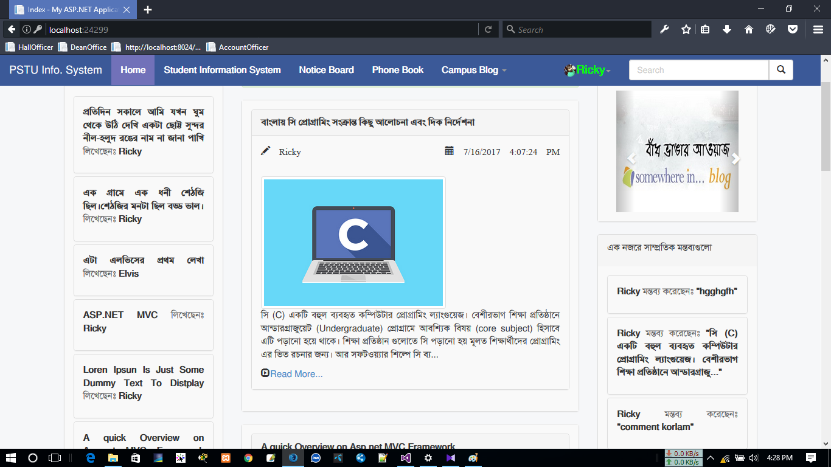

**Fig 5.1 : Member’s Forum (Blog) Home Page**

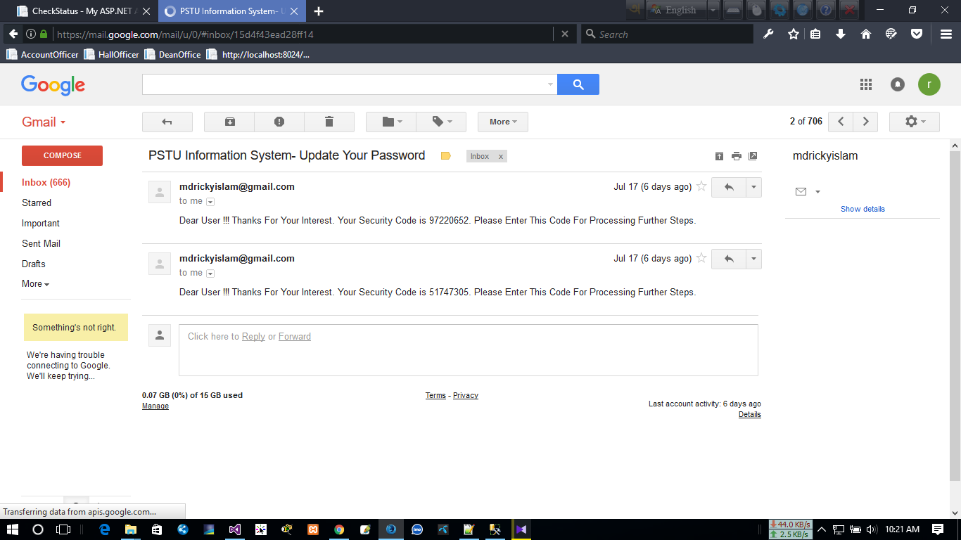

**Fig 5.2 : Mail Authenticated Password Change**

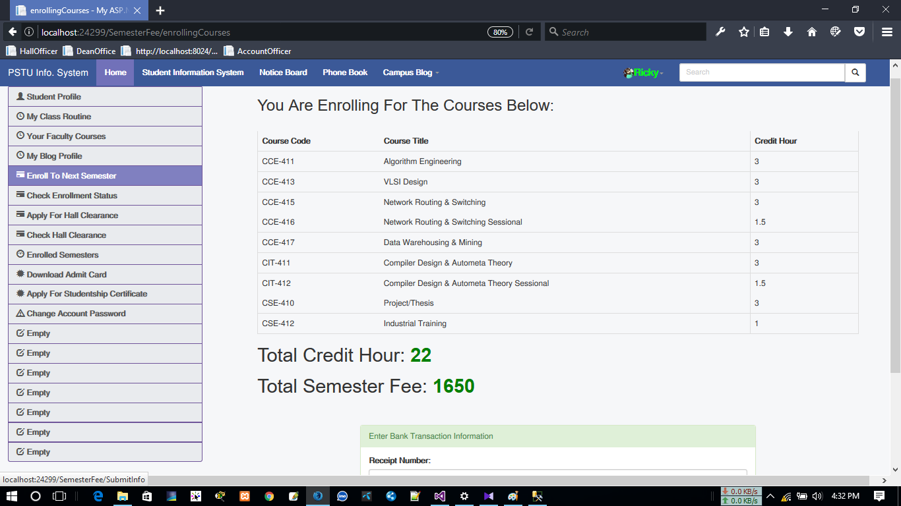

**Fig 5.3 : Next Semester Enrolling Window**

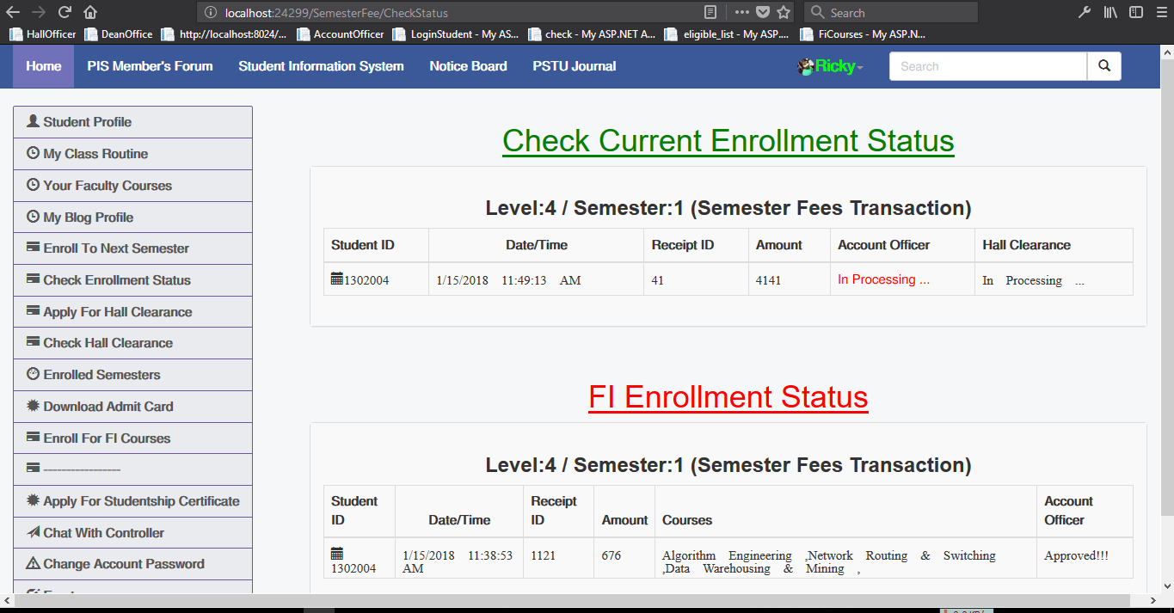

**Fig 5.4 : Check Enrollment Status**

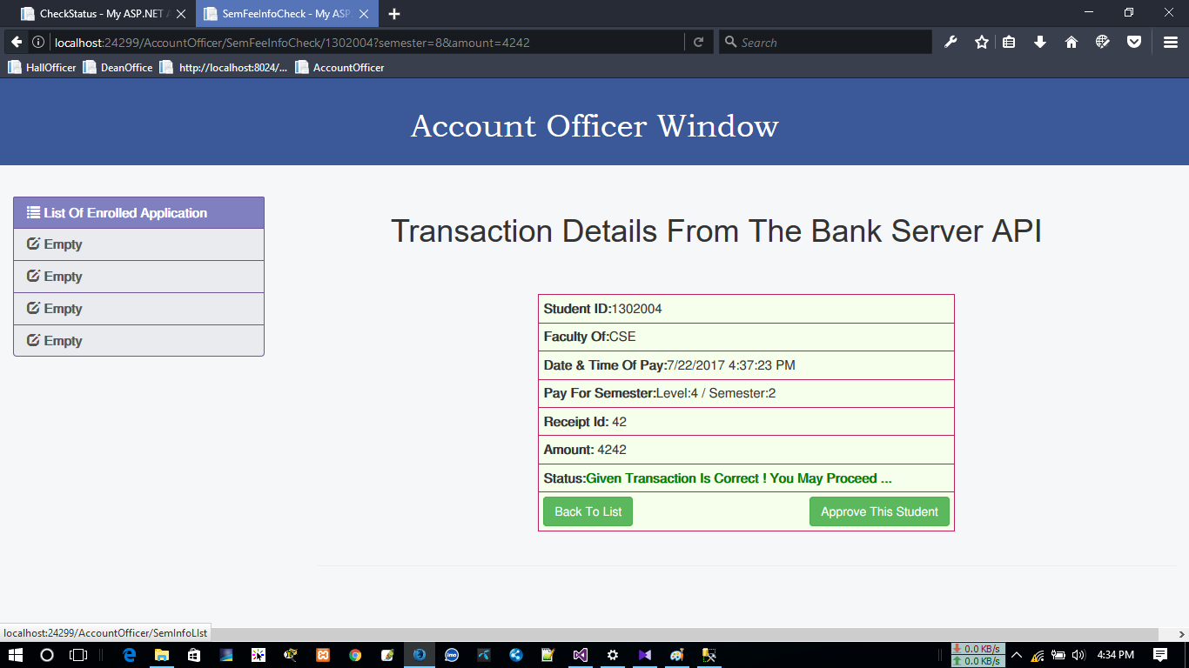

**Fig 5.5 : Transaction checking with Bank API data**

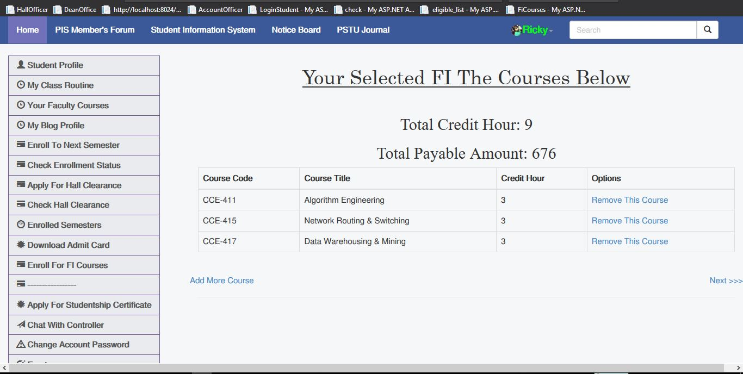

**Fig 5.6 : Fi Course Selection (Subject Cart)**

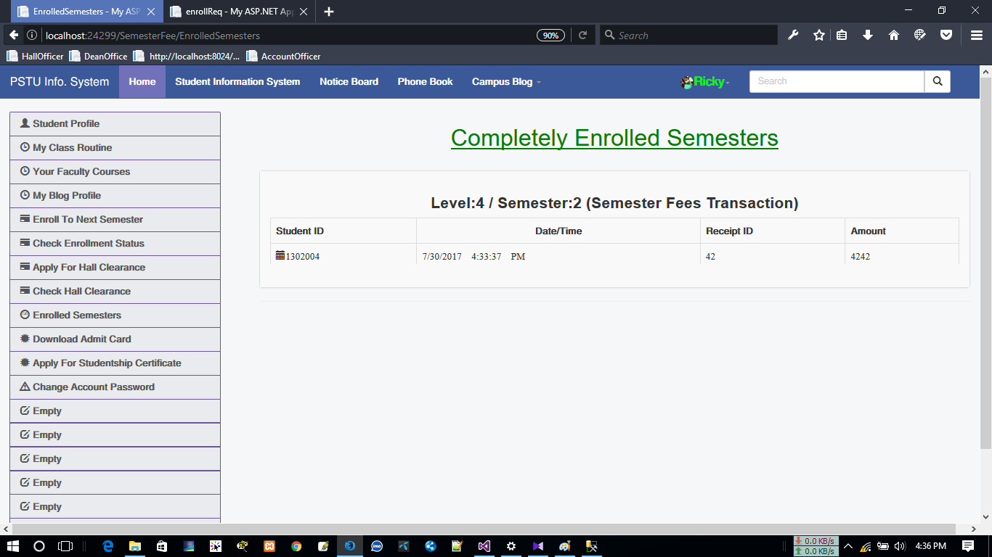

**Fig 5.7 : Enrolled Semesters**

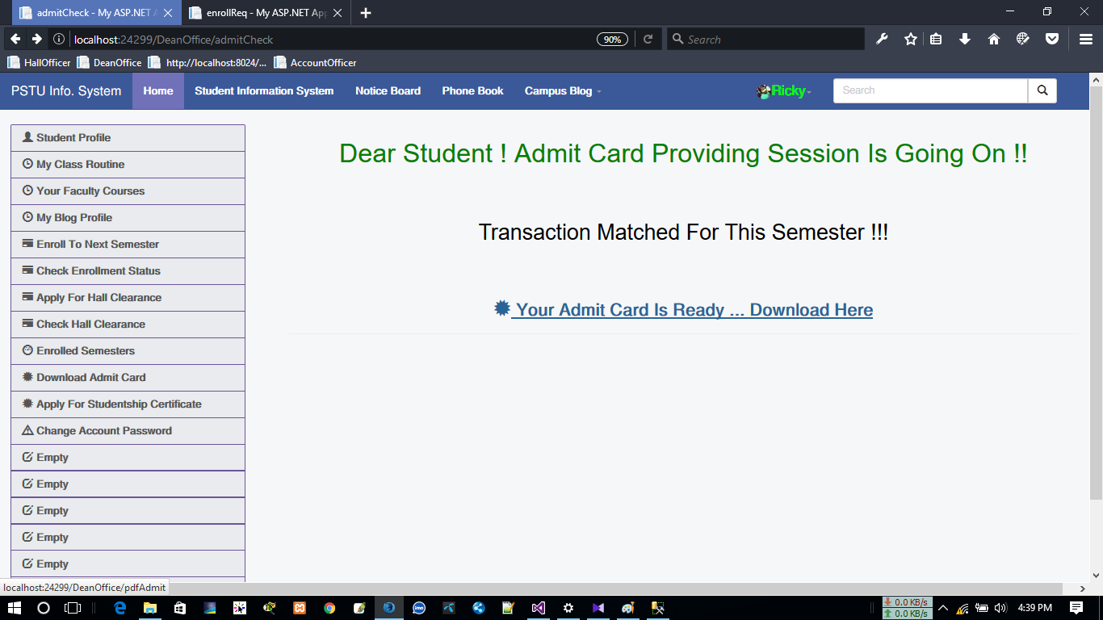

**Fig 5.8 : Download Admit Card**

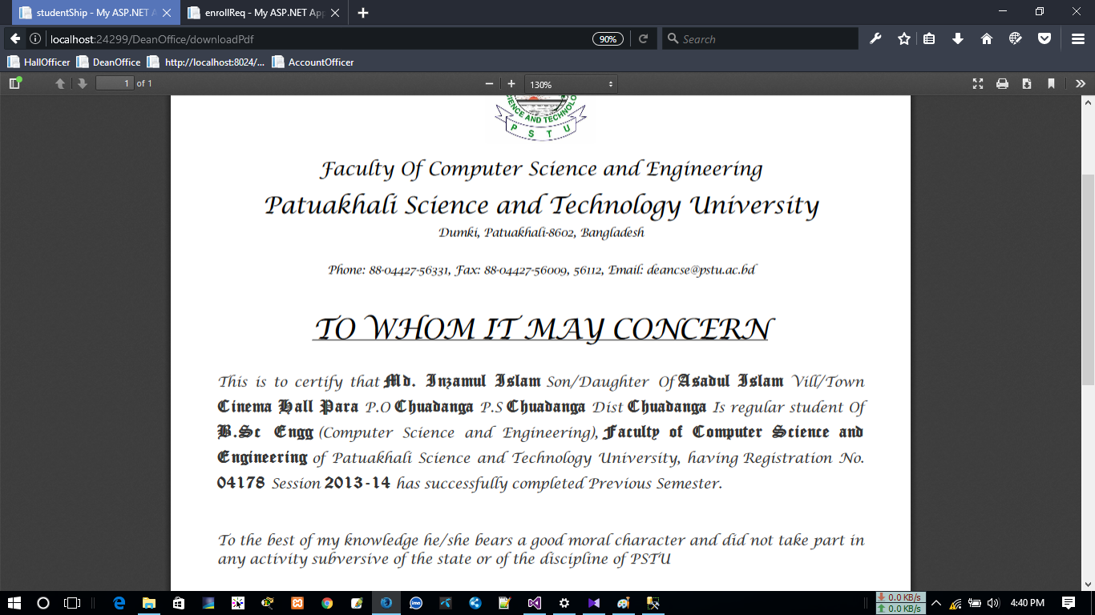

**Fig 5.9 : Download Studentship certificate**

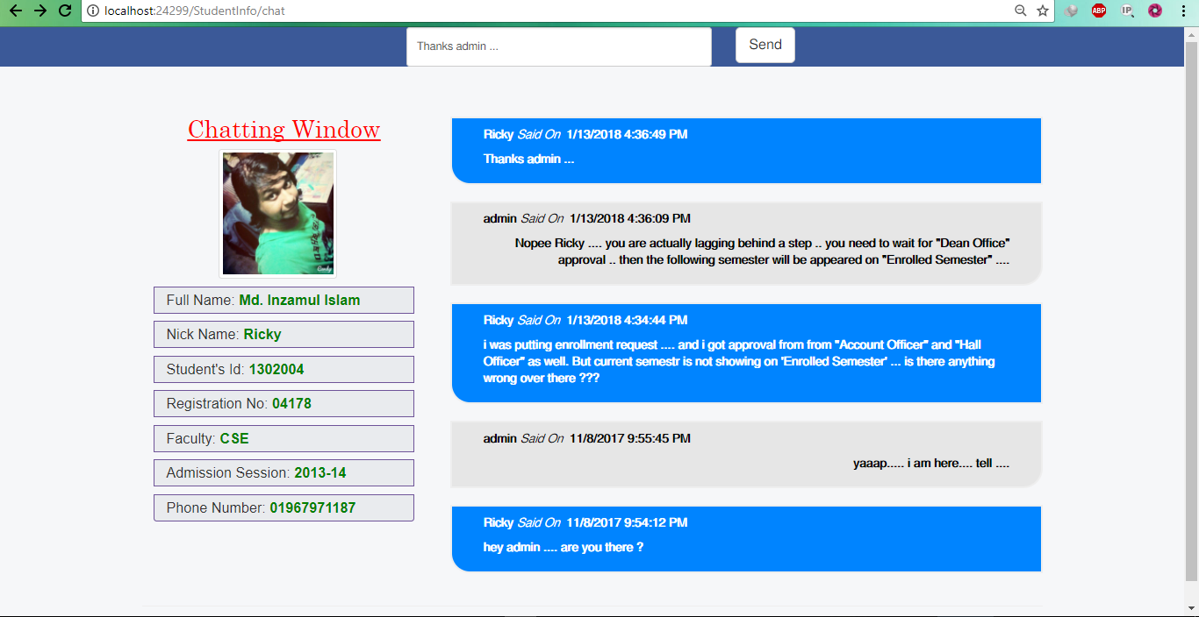

**Fig 5.10 : Live Chat With Admin**

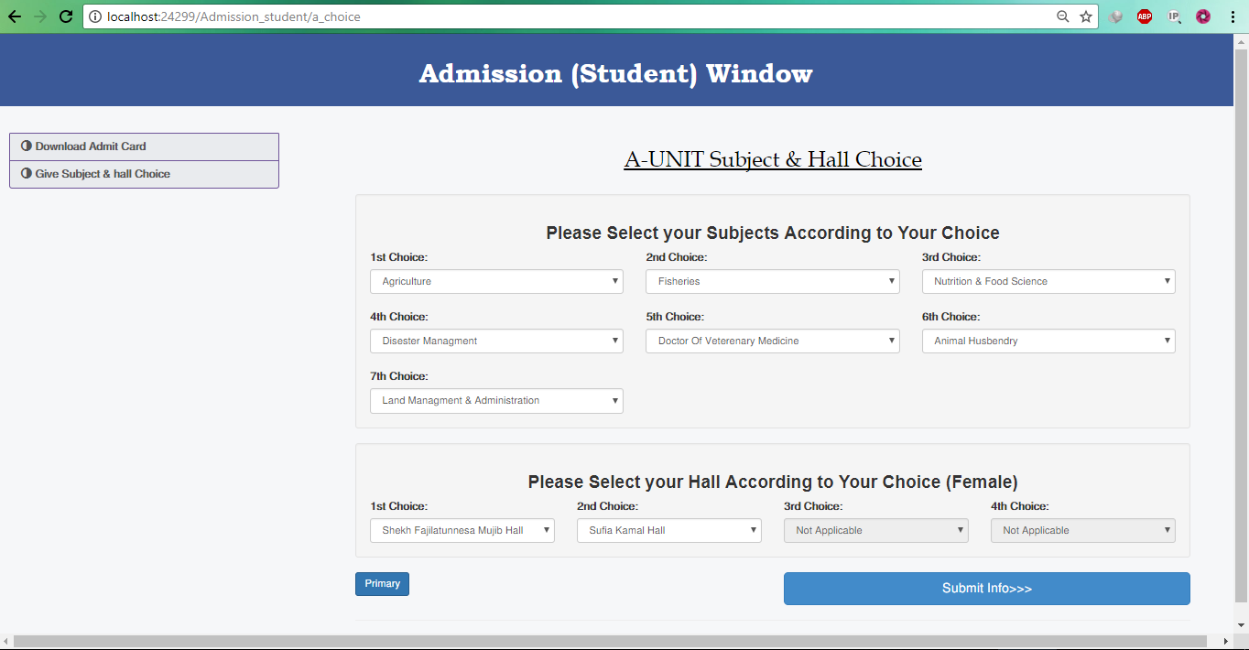

**Fig 5.11 : A-Unit Subject & Hall Choice**

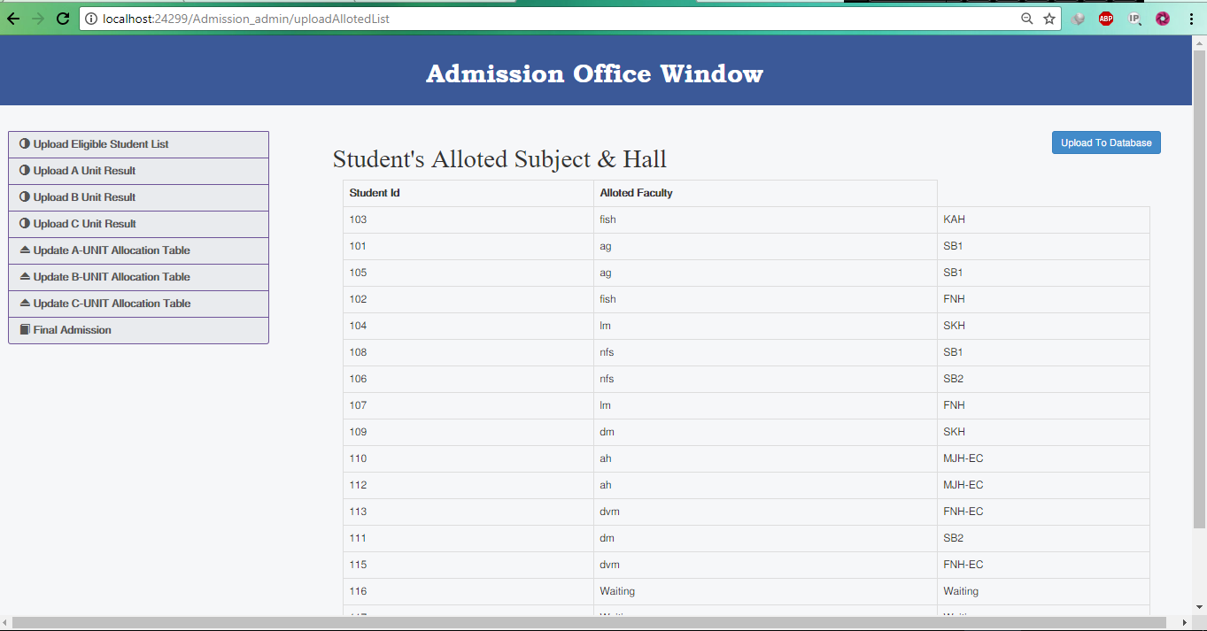

**Fig 5.12 : A-Unit Dynamic subject and Hall Allocation**

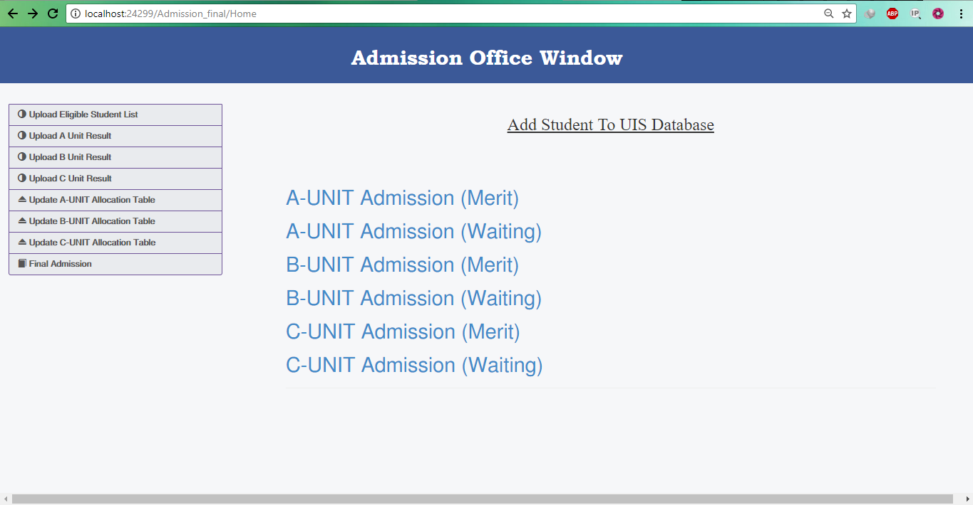

**Fig 5.13 : A-Unit Admission From Merit & Waiting**

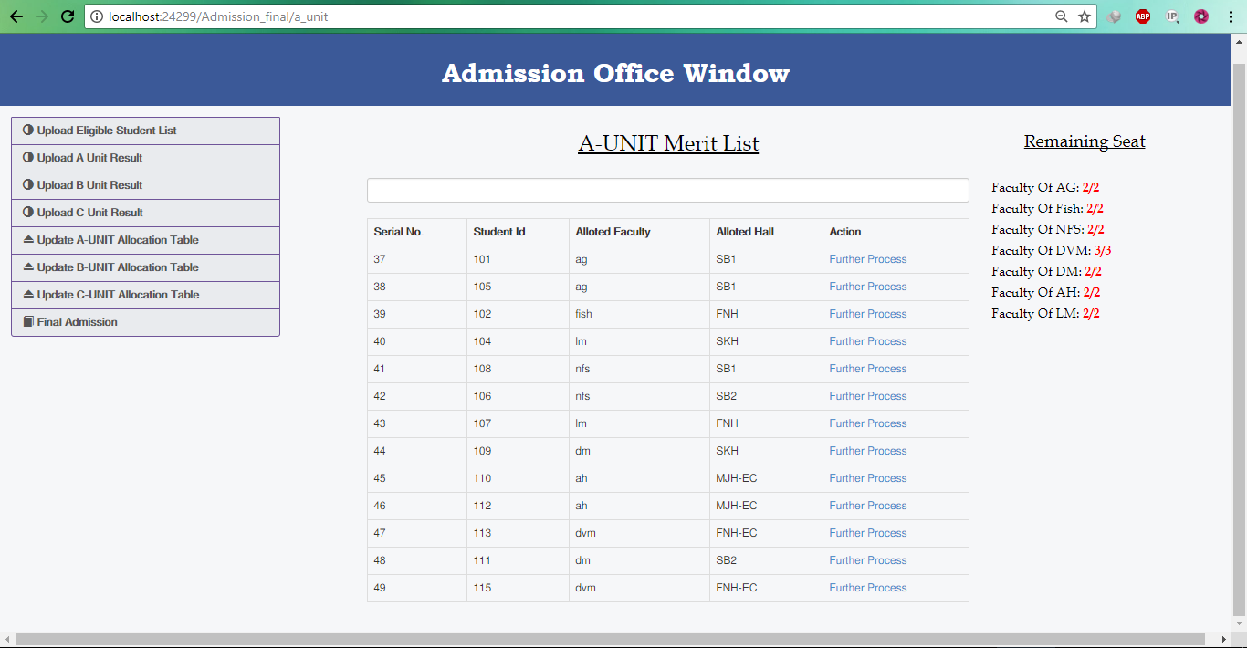

**Fig 5.14 : A-Unit (Registering Student In UIS Database**

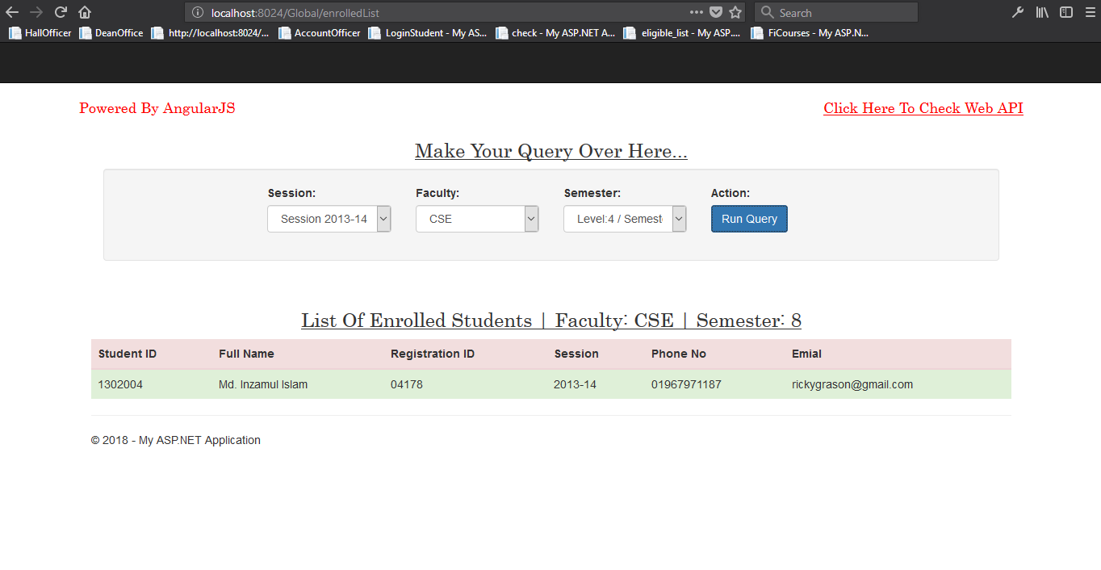

**Fig 5.15 : Global API For Getting Enroll Information**

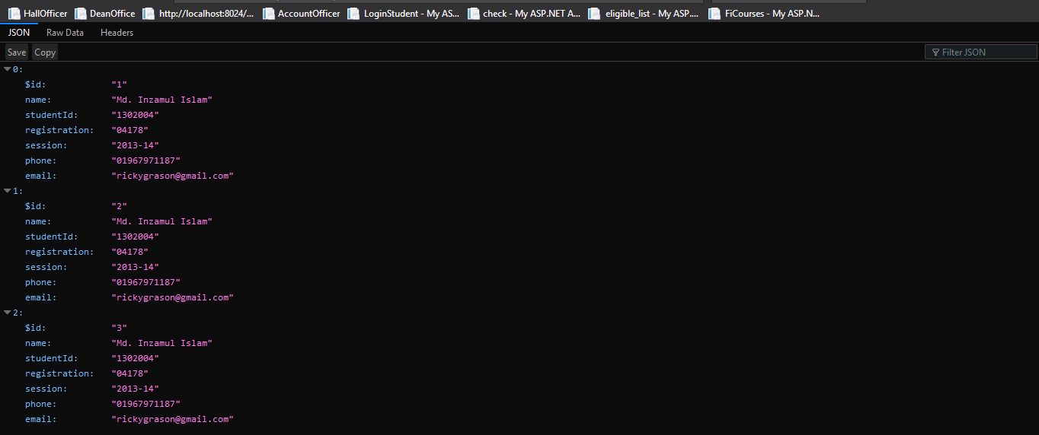

**Fig 5.16 : API Test**

CHAPTER 6

**LIMITATIONS,CONCLUSION AND FUTURE WORK**

**6.1 PROJECT SELF-EVAUTION AND LIMITATIONS**

1. Actually when you think about a ‘Information System’ it actually mean handling the total information system. As a project to develop the information system of Patuakhali Science and Technology University, it should serve the whole system. But still I am working on this project, and developed a demo of enrollment system and a Blog .
2. The Enrollment system is designed in a common way not for specific faculties.
3. There is some issue on FI removal enrollment system in my project still now.
4. Working with dummy data.
5. Not sure how it will act on remote server.
6. The project is too large to handle by a single person. So few bugs still may be remain there

**6.2 CONCLUSION AND FUTURE WORK:**

I tried my best to serve as much as possible on what I am assigned. I am admitting that this is the first time I am working with ASP.NET and its first time one a Framework and Microsoft Technology as well. So at the starting of the semester, it took much time to learn the framework, SQL SERVER database management, AngulaJS and Dot net Technology. After habituated on my development environment completely, I started my project. There is some limitations that I will try to resolve or if anyone interested in next.

1. Enrollment system with need to be specified for all the faculties.
2. Implementing AJAX Request for every case.
3. University Journal Publication system.
4. Enriching Dean Office, Account Officer and Hall Provost’s functionality on PIS website.
5. Involving Teacher’s functionality in PIS Website.